**4 CHAPTER FOUR: IMPLEMENTATION**

## 4.1 Generate Design class model to specific programming language syntax.

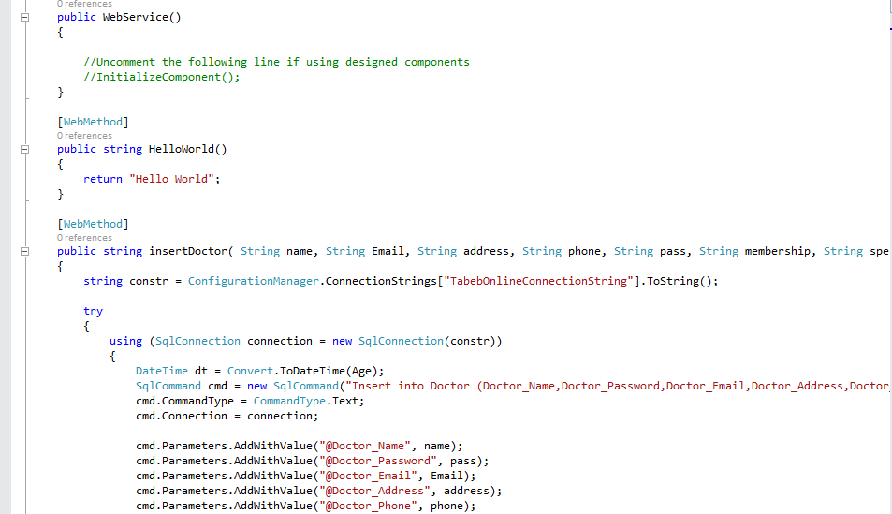

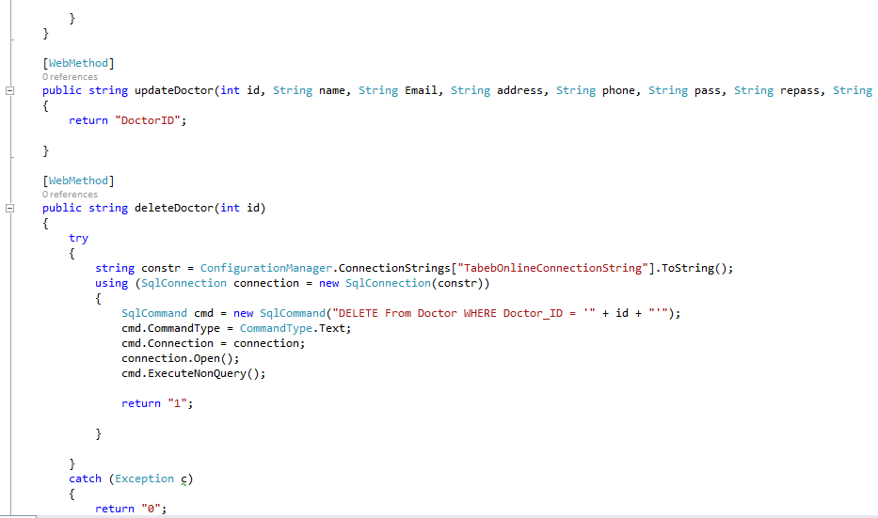

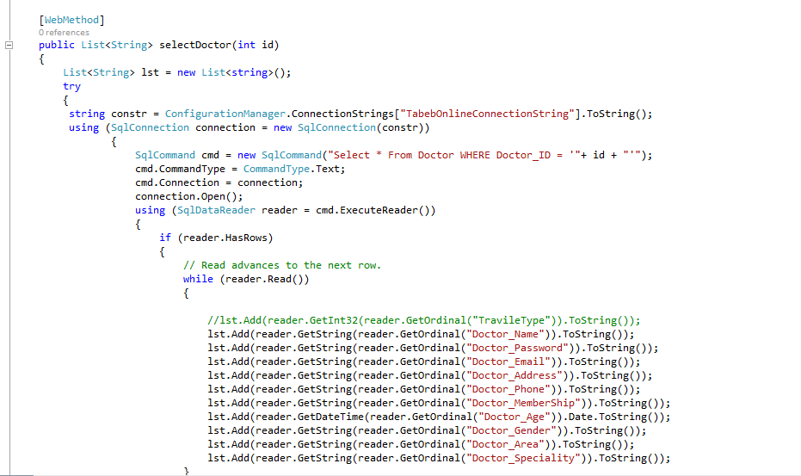

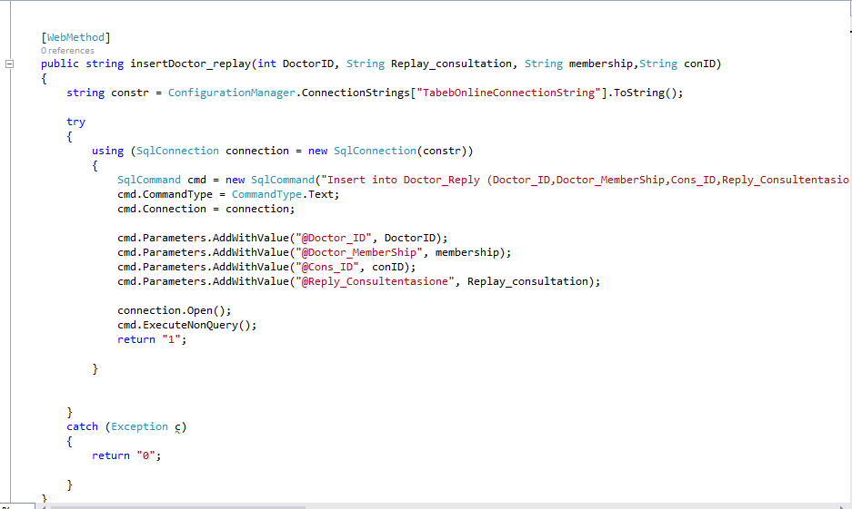

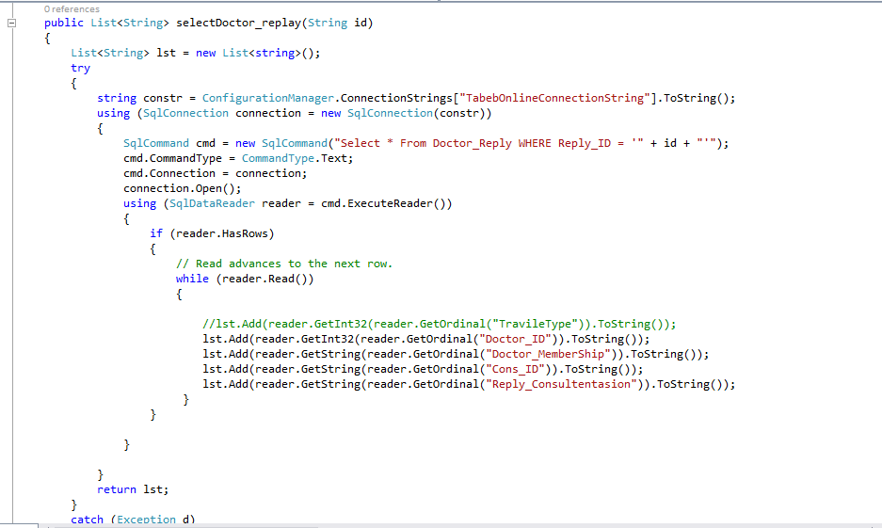

**package** com.example.alifaqeeh.graduation;  
  
**import** android.content.DialogInterface;  
**import** android.content.Intent;  
**import** android.os.Bundle;  
**import** android.support.design.widget.FloatingActionButton;  
**import** android.support.design.widget.Snackbar;  
**import** android.support.v7.app.AlertDialog;  
**import** android.support.v7.app.AppCompatActivity;  
**import** android.support.v7.widget.Toolbar;  
**import** android.view.View;  
**import** android.view.Menu;  
**import** android.view.MenuItem;  
**import** android.widget.Button;  
  
**public class** MainActivity **extends** AppCompatActivity {  
  
 Button **bD**,**bJ**;  
 @Override  
 **protected void** onCreate(Bundle savedInstanceState) {  
 **super**.onCreate(savedInstanceState);  
 setContentView(R.layout.***activity_main***);  
 Toolbar toolbar = (Toolbar) findViewById(R.id.***toolbar***);  
 setSupportActionBar(toolbar);  
  
 **bD**=(Button)findViewById(R.id.***btnDisplay***);  
 **bJ**=(Button)findViewById(R.id.***btnJoin***);  
  
  
 **bD**.setOnClickListener(**new** View.OnClickListener() {  
 @Override  
 **public void** onClick(View v) {  
 Intent intent=**new** Intent(MainActivity.**this**,Display_guest.**class**);  
 startActivity(intent);  
  
 }  
 });  
  
  
  
  
 **bJ**.setOnClickListener(**new** View.OnClickListener() {  
 @Override  
 **public void** onClick(View v) {  
 Intent intent=**new** Intent(MainActivity.**this**,Choose_page.**class**);  
 startActivity(intent);  
  
 }  
 });  
  
  
  
 }  
 @Override  
 **public void** onBackPressed() {  
 **new** AlertDialog.Builder(**this**).setIcon(android.R.drawable.***ic_dialog_alert***).setTitle(**"Exit"**)  
 .setMessage(**"Are you sure?"**)  
 .setPositiveButton(**"yes"**, **new** DialogInterface.OnClickListener() {  
 @Override  
 **public void** onClick(DialogInterface dialog, **int** which) {  
  
 Intent intent = **new** Intent(Intent.***ACTION_MAIN***);  
 intent.addCategory(Intent.***CATEGORY_HOME***);  
 intent.setFlags(Intent.***FLAG_ACTIVITY_NEW_TASK***);  
 startActivity(intent);  
 finish();  
 }  
 }).setNegativeButton(**"no"**, **null**).show();  
 }  
}

**package** com.example.alifaqeeh.graduation;  
  
**import** android.annotation.SuppressLint;  
**import** android.app.Activity;  
**import** android.content.Intent;  
**import** android.support.v7.app.ActionBar;  
**import** android.support.v7.app.AppCompatActivity;  
**import** android.os.Bundle;  
**import** android.os.Handler;  
**import** android.support.v7.widget.Toolbar;  
**import** android.view.MotionEvent;  
**import** android.view.View;  
**import** android.widget.Button;

**import** android.content.Intent;  
**import** android.os.AsyncTask;  
**import** android.support.v7.app.AppCompatActivity;  
**import** android.os.Bundle;  
**import** android.view.View;  
**import** android.widget.Button;  
**import** android.widget.EditText;  
**import** android.widget.TextView;  
**import** android.widget.Toast;  
  
**import** org.ksoap2.SoapEnvelope;  
**import** org.ksoap2.serialization.SoapObject;  
**import** org.ksoap2.serialization.SoapSerializationEnvelope;  
**import** org.ksoap2.transport.HttpTransportSE;

**import** android.animation.Animator;  
**import** android.animation.AnimatorListenerAdapter;  
**import** android.annotation.TargetApi;  
**import** android.content.Intent;  
**import** android.content.pm.PackageManager;  
**import** android.support.annotation.NonNull;  
**import** android.support.design.widget.Snackbar;  
**import** android.support.v7.app.AppCompatActivity;  
**import** android.app.LoaderManager.LoaderCallbacks;  
  
**import** android.content.CursorLoader;  
**import** android.content.Loader;  
**import** android.database.Cursor;  
**import** android.net.Uri;  
**import** android.os.AsyncTask;  
  
**import** android.os.Build;  
**import** android.os.Bundle;  
**import** android.provider.ContactsContract;  
**import** android.text.TextUtils;  
**import** android.view.KeyEvent;  
**import** android.view.View;  
**import** android.view.View.OnClickListener;  
**import** android.view.inputmethod.EditorInfo;  
**import** android.widget.ArrayAdapter;  
**import** android.widget.AutoCompleteTextView;  
**import** android.widget.Button;  
**import** android.widget.EditText;  
**import** android.widget.TextView;  
**import** android.widget.Toast;  
  
**import** org.ksoap2.SoapEnvelope;  
**import** org.ksoap2.serialization.SoapObject;  
**import** org.ksoap2.serialization.SoapSerializationEnvelope;  
**import** org.ksoap2.transport.HttpTransportSE;  
  
**import** java.util.ArrayList;  
**import** java.util.List;

**public class** Choose_page **extends** Activity {  
 Button **bL**,**bRD**,**bRP**;  
  
 @Override  
 **protected void** onCreate(Bundle savedInstanceState) {  
 **super**.onCreate(savedInstanceState);  
 setContentView(R.layout.***activity_choose_page***);  
  
  
 **bL**=(Button)findViewById(R.id.***btnLogin***);  
 **bRD**=(Button)findViewById(R.id.***btnRegDoc***);  
 **bRP**=(Button)findViewById(R.id.***btnRegPat***);  
  
  
  
 **bL**.setOnClickListener(**new** View.OnClickListener() {  
 @Override  
 **public void** onClick(View v) {  
 Intent intent=**new** Intent(Choose_page.**this**,LoginActivity.**class**);  
 startActivity(intent);  
 }  
 });  
  
 **bRP**.setOnClickListener(**new** View.OnClickListener() {  
 @Override  
 **public void** onClick(View v) {  
 Intent intent=**new** Intent(Choose_page.**this**,Register_patient.**class**);  
 startActivity(intent);  
 }  
 });  
  
 **bRD**.setOnClickListener(**new** View.OnClickListener() {  
 @Override  
 **public void** onClick(View v) {  
 Intent intent=**new** Intent(Choose_page.**this**,Register_Doc.**class**);  
 startActivity(intent);  
 }  
 });  
 }  
  
 }

**public class** Patient_Display **extends** AppCompatActivity {  
 Spinner **spSpeciality**,**spArea**;  
 Button **btnpPost**;  
 EditText **etCons**;  
 **private** Intent **getID**;  
 **private** String **idIntent**,**IDIntent**;  
 **public** String **Consultation**,**Speciality**,**Area**;  
 **private** SoapObject **array** = **null**;  
 **private** ListView **displaysPatient**;  
 List<NavItem> **listNavItems**;  
 ProgressDialog **dialog**;  
  
 **private static** String *SOAP_ACTION* = **"http://tempuri.org/insertPatient_Cons"**;  
 **private static** String *NAMESPACE* = **"http://tempuri.org/"**;  
 **private static** String *METHOD_NAME* = **"insertPatient_Cons"**;  
 **private static** String *URL* = **"http://tabeb.somee.com/webservice.asmx?WSDL"**;  
  
 @Override  
 **protected void** onCreate(Bundle savedInstanceState){  
 **super**.onCreate(savedInstanceState);  
 setContentView(R.layout.***activity_patient__display***);  
  
 **getID** = getIntent();  
 **idIntent**=**getID**.getStringExtra(**"id"**);  
  
 **displaysPatient** = (ListView)findViewById(R.id.***lstPatient***);  
  
  
  
 **dialog** = **new** ProgressDialog(Patient_Display.**this**);  
 **dialog**.setTitle(**"Loading..."**);  
 **dialog**.setMessage(**"Please wait.."**);  
 **dialog**.setIndeterminate(**true**);  
 **dialog**.setCancelable(**false**);  
 **dialog**.show();  
  
 **new** MyService().execute();  
  
  
  
  
 **spSpeciality**=(Spinner)findViewById(R.id.***speciality***);  
 String[] list=getResources().getStringArray(R.array.***speciality***);  
 ArrayAdapter<String> adapter=**new** ArrayAdapter<String>(**this**,R.layout.***spinner_layout***,R.id.***txt***,list);  
 **spSpeciality**.setAdapter(adapter);  
  
  
 **spArea**=(Spinner)findViewById(R.id.***area2***);  
 String[] list2=getResources().getStringArray(R.array.***area***);  
 ArrayAdapter<String> adapter2=**new** ArrayAdapter<String>(**this**,R.layout.***spinner_layout***,R.id.***txt***,list2);  
 **spArea**.setAdapter(adapter2);  
  
 **etCons** = (EditText)findViewById(R.id.***etcons***);  
  
 **btnpPost** = (Button) findViewById(R.id.***btnSend***);  
 **btnpPost**.setOnClickListener(**new** View.OnClickListener() {  
 @Override  
 **public void** onClick(View v) {  
  
  
 **if** (**etCons**.getText().toString().equals(**""**))  
 {  
 Toast.*makeText*(Patient_Display.**this**, **"write your consultation"**, Toast.***LENGTH_SHORT***).show();  
 }  
 **else** {  
 **Consultation** = **etCons**.getText().toString();  
 **Speciality** = **spSpeciality**.getSelectedItem().toString();  
 **Area** = **spArea**.getSelectedItem().toString();  
  
 **getID** = getIntent();  
 **IDIntent** = **getID**.getStringExtra(**"id"**);  
  
 **new** LongOperation().execute(**""**);  
 }  
 }  
 });  
  
  
  
 }

**private class** LongOperation **extends** AsyncTask<String, Void, String> {  
  
  
  
 @Override  
 **protected** String doInBackground(String... params) {  
 **try** {  
  
  
 SoapObject request = **new** SoapObject(*NAMESPACE*, *METHOD_NAME*);  
  
  
 *//Use this to add parameters* request.addProperty(**"consultation"**,**Consultation**);  
 request.addProperty(**"PationtID"**,**idIntent**);  
 request.addProperty(**"Email"**,**"Speciality: "** + **Speciality** + **" Area:"**+**Area**);  
  
  
 *//Declare the version of the SOAP request* SoapSerializationEnvelope envelope = **new** SoapSerializationEnvelope(SoapEnvelope.***VER11***);  
  
 envelope.setOutputSoapObject(request);  
 envelope.**dotNet** = **true**;  
  
 **try** {  
 HttpTransportSE androidHttpTransport = **new** HttpTransportSE(*URL*);  
  
 *//this is the actual part that will call the webservice* androidHttpTransport.call(*SOAP_ACTION*, envelope);  
  
 *// Get the SoapResult from the envelope body.* SoapObject result = (SoapObject)envelope.**bodyIn**;  
  
 **if**(result != **null**)  
 {  
 **if**(result.getProperty(0).toString().equals(**"1"**))  
 {  
 runOnUiThread(**new** Runnable() {  
  
 **public void** run() {  
  
 Toast.*makeText*(getApplicationContext(), **"Successfully ... thank you"**, Toast.***LENGTH_LONG***).show();  
 *// Intent intent=new Intent(Patient_Display.this,Display_guest.class);  
 // startActivity(intent);* }  
 });  
 }  
 **else if**(result.getProperty(0).toString().equals(**"0"**))  
 {  
 runOnUiThread(**new** Runnable() {  
  
 **public void** run() {  
  
 Toast.*makeText*(getApplicationContext(),**"Error ... Try Again"**,Toast.***LENGTH_LONG***).show();  
  
 }  
 });  
  
 }  
  
 }  
 **else** {  
 Toast.*makeText*(getApplicationContext(), **"No Response"**,Toast.***LENGTH_LONG***).show();  
 }  
 } **catch** (Exception e) {  
 e.printStackTrace();  
 }  
  
  
 }  
 **catch** (Exception c)  
 {  
 }  
 **return "Executed"**;  
 }  
  
 @Override  
 **protected void** onPostExecute(String result) {  
  
  
 }  
  
 @Override  
 **protected void** onPreExecute() {}  
  
 @Override  
 **protected void** onProgressUpdate(Void... values) {}  
}  
  
  
  
  
  
  
  
  
  
  
  
  
  
  
  
**private class** MyService **extends** AsyncTask {  
 **private** String **TAG**;  
 SoapPrimitive **DisplayName**;  
 ArrayList<String> **cons** = **new** ArrayList<String>();  
  
 @Override  
 **protected** Object doInBackground(Object[] objects) {  
 **try** {  
  
 String Name_Space = **"http://tempuri.org/"**;  
 String URL = **"http://tabeb.somee.com/webservice.asmx?WSDL"**;  
 String Method = **"selectAllPatient_Cons"**;  
 String Soap_Action = **"http://tempuri.org/selectAllPatient_Cons"**;  
  
 SoapObject request = **new** SoapObject(Name_Space, Method);  
 *//request.addProperty("_worker", sql.getRecId());//Username.getText());* SoapSerializationEnvelope envelope =  
 **new** SoapSerializationEnvelope(SoapEnvelope.***VER11***);  
 envelope.**dotNet** = **true**;  
 envelope.setOutputSoapObject(request);  
  
 HttpTransportSE androidHttpTransport = **new** HttpTransportSE(URL);  
  
 androidHttpTransport.call(Soap_Action, envelope);  
  
 SoapObject _object = (SoapObject) envelope.**bodyIn**;  
 **array** = (SoapObject) _object.getProperty(0);  
  
  
 **int** cou = 0;  
 **for** (**int** i = 0; i <= **array**.getPropertyCount(); i++) {  
 **try** {  
 **DisplayName** = (SoapPrimitive) **array**.getProperty(i) ;  
 Log.*d*(**TAG**, **DisplayName**.toString());  
 **cons**.add(**DisplayName**.toString());  
  
  
 } **catch** (Exception e) {  
 }  
  
 }  
 **return true**;  
 } **catch** (IOException e) {  
 e.printStackTrace();  
 **return false**;  
 } **catch** (XmlPullParserException e) {  
 e.printStackTrace();  
 **return false**;  
 }  
 }  
  
 @Override  
 **protected void** onPostExecute(Object o) {  
 **super**.onPostExecute(o);  
 **listNavItems** = **new** ArrayList<NavItem>();  
  
 **int** c = 0, v = 0;  
  
 **for** (**int** s = 0; s <= **cons**.size(); s++) {  
 c++;  
 **if** (c == 4) {  
  
 **listNavItems**.add(**new** NavItem(**cons**.get(0 + v), **cons**.get(1 + v), **cons**.get(2 + v), **cons**.get(3 + v)));  
 v += 4;  
 c = 0;  
 }  
  
 }  
  
 NavListAdapter navListAdapter = **new** NavListAdapter(  
 getApplicationContext(), R.layout.***activity_item__nav__list***, **listNavItems**);  
  
 **displaysPatient**.setAdapter(navListAdapter);  
  
  
  
  
 **displaysPatient**.setOnItemClickListener(**new** AdapterView.OnItemClickListener()  
 {  
 @Override  
 **public void** onItemClick(AdapterView<?> parent, View view, **int** position, **long** id) {  
  
 TextView tv = (TextView) view.findViewById(R.id.***tvid***);  
 TextView tvCon = (TextView) view.findViewById(R.id.***cons***);  
 Intent intent = **new** Intent(Patient_Display.**this**,ShowComment.**class**);  
 intent.putExtra(**"id"**,tv.getText().toString());  
 intent.putExtra(**"con"**,tvCon.getText().toString());  
  
 startActivity(intent);  
 }  
  
 });  
 **dialog**.dismiss();  
  
 }  
  
  
}  
@Override  
  
**public void** onBackPressed() {  
 **new** AlertDialog.Builder(Patient_Display.**this**).setIcon(android.R.drawable.***ic_dialog_alert***).setTitle(**"Exit"**)  
 .setMessage(**"Are you sure?"**)  
 .setPositiveButton(**"yes"**, **new** DialogInterface.OnClickListener() {  
 @Override  
 **public void** onClick(DialogInterface dialog, **int** which) {  
  
 Intent intent = **new** Intent(Intent.***ACTION_MAIN***);  
 intent.addCategory(Intent.***CATEGORY_HOME***);  
 intent.setFlags(Intent.***FLAG_ACTIVITY_NEW_TASK***);  
 startActivity(intent);  
 finish();  
 }  
 }).setNegativeButton(**"no"**, **null**).show();  
}}

**public class** Register_Doc **extends** AppCompatActivity {  
 Button **btnsubmet**;  
 EditText **etname**,**etmail**,**etaddress**,**etphone**,**etmembership**,**etpass**,**etrepass**;  
 **public** String **name**,**mail**,**address**,**phone**,**pass**,**membership**,**repass**,**spec**,**area**,**gender**;  
 **private** Intent **getEmail**,**getDocID**;  
 **private** String **EmailIntent**,**IDIntent**;  
 RadioButton **rdmale**,**rdfemale**;  
 Spinner **spSpeci**,**spAreaa**;  
  
 **private static** String *SOAP_ACTION* = **"http://tempuri.org/insertDoctor"**;  
 **private static** String *NAMESPACE* = **"http://tempuri.org/"**;  
 **private static** String *METHOD_NAME* = **"insertDoctor"**;  
 **private static** String *URL* = **"http://tabeb.somee.com/webservice.asmx?WSDL"**;  
  
  
 @Override  
 **protected void** onCreate(Bundle savedInstanceState) {  
 **super**.onCreate(savedInstanceState);  
 setContentView(R.layout.***activity_register__doc***);  
  
  
 **rdmale**=(RadioButton)findViewById(R.id.***rdmale***);  
 **rdfemale**=(RadioButton)findViewById(R.id.***rdfemale***);  
  
 **etname** = (EditText)findViewById(R.id.***etnamed***);  
 **etmail** = (EditText)findViewById(R.id.***etMaild***);  
 **etaddress** = (EditText)findViewById(R.id.***etAddressd***);  
 **etphone** = (EditText)findViewById(R.id.***etPhoned***);  
 **etmembership** = (EditText)findViewById(R.id.***etMembership***);  
 **etpass** = (EditText)findViewById(R.id.***etPassd***);  
 **etrepass** = (EditText)findViewById(R.id.***etRePassd***);  
  
  
 **spSpeci** = (Spinner)findViewById(R.id.***spSpeci***);  
 String[] list=getResources().getStringArray(R.array.***speciality***);  
 ArrayAdapter<String> adapter=**new** ArrayAdapter<String>(**this**,R.layout.***spinner_l2***,R.id.***txt2***,list);  
 **spSpeci**.setAdapter(adapter);  
  
  
 **spAreaa**=(Spinner)findViewById(R.id.***spArea***);  
 String[] list2=getResources().getStringArray(R.array.***area***);  
 ArrayAdapter<String> adapter2=**new** ArrayAdapter<String>(**this**,R.layout.***spinner_l2***,R.id.***txt2***,list2);  
  
 **spAreaa**.setAdapter(adapter2);  
  
  
  
  
  
 **btnsubmet**=(Button) findViewById(R.id.***btnRegDocDone***);  
 **btnsubmet**.setOnClickListener(**new** View.OnClickListener() {  
 @Override  
 **public void** onClick(View v) {  
  
  
  
 **name** = **etname**.getText().toString();  
 **mail** = **etmail**.getText().toString();  
 **address** = **etaddress**.getText().toString();  
 **phone** = **etphone**.getText().toString();  
 **membership** = **etmembership**.getText().toString();  
 **pass** = **etpass**.getText().toString();  
 **repass** = **etrepass**.getText().toString();  
  
 **spec** = **spSpeci**.getSelectedItem().toString();  
 **area** = **spAreaa**.getSelectedItem().toString();  
  
 **if**(**rdmale**.isChecked() == **true**)  
 **gender** = **"1"**;  
 **else  
 gender** = **"2"**;  
  
 **if** (**name**.equals(**""**)||!**mail**.contains(**"@"**)||**address**.equals(**""**)||**phone**.equals(**""**)  
 ||**membership**.equals(**""**)||**pass**.equals(**""**)||**spec**.equals(**"choose Speciality"**)  
 ||**area**.equals(**"choose Area"**))  
 {  
 Toast.*makeText*(Register_Doc.**this**, **"Please fill in all fields correctly"**, Toast.***LENGTH_SHORT***).show();  
 }  
 **else** {  
 **if** (**pass**.equals(**repass**)) {  
 **new** LongOperation().execute(**""**);  
 }  
 **else** Toast.*makeText*(Register_Doc.**this**, **"Please be sure to write Password"**, Toast.***LENGTH_SHORT***).show();  
  
 }  
  
  
  
 }  
 });  
  
 }

**public class** ShowComment **extends** AppCompatActivity {  
  
 **private** ListView **list**;  
 **private** TextView **tv**;  
  
 **private** SoapObject **array** = **null**;;  
 List<NavItem_Replay> **listNavItems**;  
 **private** Intent **getID**;  
 **private** String **idIntent**,**cons**,**replyID**;  
 ProgressDialog **dialog**;  
  
 @Override  
 **protected void** onCreate(Bundle savedInstanceState) {  
 **super**.onCreate(savedInstanceState);  
 setContentView(R.layout.***activity_show_comment***);  
 Toolbar toolbar = (Toolbar) findViewById(R.id.***toolbar***);  
 setSupportActionBar(toolbar);  
  
 **list** = (ListView) findViewById(R.id.***lv***);  
 **tv** = (TextView) findViewById(R.id.***tvCons***);  
 **getID** = getIntent();  
 **idIntent** = **getID**.getStringExtra(**"id"**);  
 **cons** = **getID**.getStringExtra(**"con"**);  
 **tv**.setText(**cons**);  
  
  
 **dialog** = **new** ProgressDialog(ShowComment.**this**);  
 **dialog**.setTitle(**"Loading..."**);  
 **dialog**.setMessage(**"Please wait.."**);  
 **dialog**.setIndeterminate(**true**);  
 **dialog**.setCancelable(**false**);  
 **dialog**.show();  
  
  
  
  
  
 **list**.setOnItemLongClickListener(**new** AdapterView.OnItemLongClickListener() {  
 @Override  
 **public boolean** onItemLongClick(AdapterView<?> parent, View view, **int** position, **long** id) {  
  
  
  
 **getID** = getIntent();  
 TextView tv = (TextView) view.findViewById(R.id.***tvid***);  
 Intent intent=**new** Intent(ShowComment.**this**,PrfileDoc.**class**);  
  
 intent.putExtra(**"id"**,tv.getText().toString());  
 Toast.*makeText*(ShowComment.**this**, **"Docccc "**+tv.getText().toString(), Toast.***LENGTH_SHORT***).show();  
 startActivity(intent);  
  
  
 **return true**;  
 }  
 });  
  
  
  
  
  
  
  
  
  
 **new** MyService().execute();  
  
 FloatingActionButton fab = (FloatingActionButton) findViewById(R.id.***fab***);  
 fab.setOnClickListener(**new** View.OnClickListener() {  
 @Override  
 **public void** onClick(View view) {  
 Snackbar.*make*(view, **"This consultation is Doctor's opinion and not our opinion"**, Snackbar.***LENGTH_LONG***)  
 .setAction(**"Action"**, **null**).show();  
 }  
 });  
 **dialog**.dismiss();  
  
 }  
  
  
 **private class** MyService **extends** AsyncTask {  
 **private** String **TAG**;  
 SoapPrimitive **DisplayName**;  
 ArrayList<String> **cons**=**new** ArrayList<String>();  
  
 @Override  
 **protected** Object doInBackground(Object[] objects) {  
 **try** {  
  
 String Name_Space = **"http://tempuri.org/"**;  
 String URL = **"http://tabeb.somee.com/webservice.asmx?WSDL"**;  
 String Method = **"selectDoctor_replayByCons"**;  
 String Soap_Action = **"http://tempuri.org/selectDoctor_replayByCons"**;  
  
 SoapObject request = **new** SoapObject(Name_Space, Method);  
 request.addProperty(**"id"**, **idIntent**);*//Username.getText());* SoapSerializationEnvelope envelope =  
 **new** SoapSerializationEnvelope(SoapEnvelope.***VER11***);  
 envelope.**dotNet** = **true**;  
 envelope.setOutputSoapObject(request);  
  
 HttpTransportSE androidHttpTransport = **new** HttpTransportSE(URL);  
  
 androidHttpTransport.call(Soap_Action, envelope);  
  
 SoapObject _object = (SoapObject) envelope.**bodyIn**;  
 **array** = (SoapObject) _object .getProperty(0);  
  
  
 **int** cou=0;  
 **for**(**int** i =0;i <= **array**.getPropertyCount();i++) {  
 **try** {  
 **DisplayName** = (SoapPrimitive) **array**.getProperty(i);*// this is--> // property 0 [0] ;* Log.*d*(**TAG**, **DisplayName**.toString());  
 **cons**.add( **DisplayName**.toString());  
  
 */*DisplayName = (SoapPrimitive) array.getProperty(1 + cou);// this is--> // property 0 [0] ;  
 Log.d(TAG, DisplayName.toString());  
 cons.add( DisplayName.toString());  
  
 DisplayName = (SoapPrimitive) array.getProperty(2 + cou);// this is--> // property 0 [0] ;  
 Log.d(TAG, DisplayName.toString());  
 cons.add( DisplayName.toString());  
 cou = cou + 3;*/* } **catch** (Exception e) {  
 }  
  
 }  
 **return true**;  
 } **catch** (IOException e) {  
 e.printStackTrace();  
 **return false**;  
 } **catch** (XmlPullParserException e) {  
 e.printStackTrace();  
 **return false**;  
 }  
 }  
  
  
  
 @Override  
 **protected void** onPostExecute(Object o) {  
 **super**.onPostExecute(o);  
 **listNavItems** = **new** ArrayList<NavItem_Replay>();  
  
 **int** c = 0 , v = 0;  
 **for** (**int** s = 0; s <= **cons**.size();s++)  
 {  
 c++;  
 **if**(c == 4)  
 {  
  
 **listNavItems**.add(**new** NavItem_Replay(**"Doctor: "**+**cons**.get(0 + v),**cons**.get(3 + v),**cons**.get(1 + v)));  
 v += 4;  
 c = 0;  
 }  
  
 }  
  
 NavListAdapter_Replay navListAdapter = **new** NavListAdapter_Replay(  
 getApplicationContext(), R.layout.***item__nav__list_replay***, **listNavItems**);  
  
 **list**.setAdapter(navListAdapter);  
  
  
 **dialog**.dismiss();  
  
  
  
 }  
  
 }  
  
}

**public class** Replay_Doc **extends** AppCompatActivity {  
  
 EditText **text**;  
 Button **button**;  
  
 **private** Intent **getConsID**,**getDocID**,**getReplyID**;  
 **private** String **ConsIntent**,**IDIntent**,**IDReplyIntent**;  
  
  
 **private static** String *SOAP_ACTION* = **"http://tempuri.org/insertDoctor_replay"**;  
 **private static** String *NAMESPACE* = **"http://tempuri.org/"**;  
 **private static** String *METHOD_NAME* = **"insertDoctor_replay"**;  
 **private static** String *URL* = **"http://tabeb.somee.com/webservice.asmx?WSDL"**;  
  
 **public** String **Reply**;  
  
  
 @Override  
 **protected void** onCreate(Bundle savedInstanceState) {  
 **super**.onCreate(savedInstanceState);  
 setContentView(R.layout.***activity_replay__doc***);  
  
  
 **text** = (EditText)findViewById(R.id.***txtreplay***);  
 **button** = (Button)findViewById(R.id.***btnReplay***);  
  
  
  
 **button**.setOnClickListener(**new** View.OnClickListener() {  
 @Override  
 **public void** onClick(View v) {  
  
  
 **if** (**text**.getText().toString().equals(**""**))  
 {  
 Toast.*makeText*(Replay_Doc.**this**, **"write a reply please "**, Toast.***LENGTH_SHORT***).show();  
 }  
  
 **else** {  
  
 **Reply** = **text**.getText().toString();  
  
  
 **getConsID** = getIntent();  
 **ConsIntent** = **getConsID**.getStringExtra(**"id"**);  
  
  
 **getDocID** = getIntent();  
 **IDIntent** = **getDocID**.getStringExtra(**"DoctorID"**);  
  
  
  
  
  
 Toast.*makeText*(Replay_Doc.**this**, **"sss "**+**ConsIntent**, Toast.***LENGTH_SHORT***).show();  
 Toast.*makeText*(Replay_Doc.**this**, **"fff "**+**IDIntent**, Toast.***LENGTH_SHORT***).show();  
  
 **new** LongOperation().execute(**""**);  
 }  
 }  
 });  
  
  
 }